Troubleshooting downloads with WebUSB

**Step 1: Check your cable**

Make sure that your micro:bit is connected to your computer with a micro USB cable. You should see a ****MICROBIT**** drive appear in Windows Explorer when it’s connected.

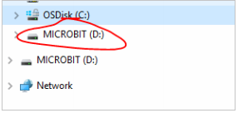

****If you can see the MICROBIT drive go to step 2****.

If you can’t see the drive:

* Make sure that the USB cable is working. >Does the cable work on another computer? If not, find a different cable to use. Some cables may only provide a power connection and don’t actually transfer data.
* Try another USB port on your computer.

Is the cable good but you still can’t see the ****MICROBIT**** drive? Hmm, you might have a problem with your micro:bit. Try the additional steps described in the[falut finding](https://support.microbit.org/support/solutions/articles/19000024000-fault-finding-with-a-micro-bit)page at microbit.org. If this doesn’t help, you can create a [support ticket](https://support.microbit.org/support/tickets/new) to notify the Micro:bit Foundation of the problem. ****Skip the rest of these steps****.

**Step 2: Check your firmware version**

It’s possible that the firmware version on the micro:bit needs an update. Let’s check:

1. Go to the ****MICROBIT**** drive.
2. Open the ****DETAILS.TXT**** file.

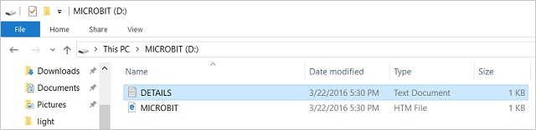

1. Look for a line in the file that says the version number. It should say ****Version: ...****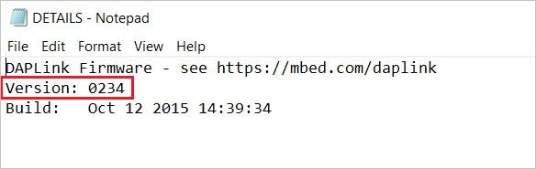

or ****Interface Version: ...****

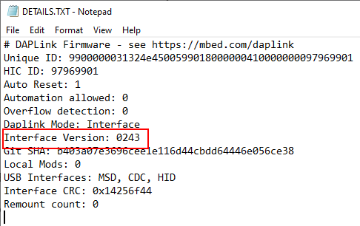

If the version is ****0234****, ****0241****, ****0243**** you ****NEED**** to update the [firmware](https://makecode.microbit.org/device/firmware) on your micro:bit. Go to ****Step 3**** and follow the upgrade instructions.

If the version is ****0249****, ****0250**** or higher, ****you have the right firmware**** go to step ****4****.

**Step 3: Update the firmware**

1. Put your micro:bit into ****MAINTENANCE Mode****. To do this, unplug the USB cable from the micro:bit and then re-connect the USB cable while you hold down the reset button. Once you insert the cable, you can release the reset button. You should now see a ****MAINTENANCE**** drive instead of the ****MICROBIT**** drive like before. Also, a yellow LED light will stay on next to the reset button.

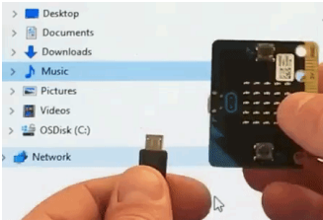

1. **[Download the firmware .hex file](https://microbit.org/guide/firmware/" \t "https://makecode.microbit.org/device/usb/webusb/_blank)**

(<https://microbit.org/guide/firmware/>)

3.Drag and drop that file onto the ****MAINTENANCE**** drive.

4. The yellow LED will flash while the HEX file is copying. When the copy finishes, the LED will go off and the micro:bit resets. The ****MAINTENANCE**** drive now changes back to ****MICROBIT****.

5. The upgrade is complete! You can open the ****DETAILS.TXT**** file to check and see that the firmware version changed to the match the version of the ****HEX**** file you copied.

If you want to know more about connecting the board, MAINTENANCE Mode, and upgrading the firmware, read about it in the [Firmware guide](https://microbit.org/guide/firmware/).

**Step 4: Check over version of Browser**

WebUSB is a fairly new feature and may require you to update your browser. Check that your browser version matches one of these:

* Chrome 65+ for Android, Chrome OS, Linux, macOS and Windows 10.

**Step 5: Pair device**

Once you’ve updated the firmware, open the ****Chrome Browser****, go to the editor and click on ****Pair Device**** in the gearwheel menu. See [WebUSB](https://makecode.microbit.org/device/usb/webusb) for pairing instructions.

Enjoy fast downloads!